**Computer Graphic interim report**

Progress:

Finish all features the proposal mention.

Include:

Project main target:

Each of the planets should revolution to the sun and rotate itself.

Each of the planets should have different surface.

The speed of revolution and rotate should be adjustable by some key. The camera should control by mouse or keyboard that user can change the perspective of the scene.

Project extra target:

There should have a background of the universe. Add extra satellites to the planets.

Extra features:

Use skybox as the background of the universe.

Implement particle system. (transparent texture, control of the particle active or not)

Add asteroid belt to the solar system.

The atmosphere of earth.

Demo pic:

Whole scene:

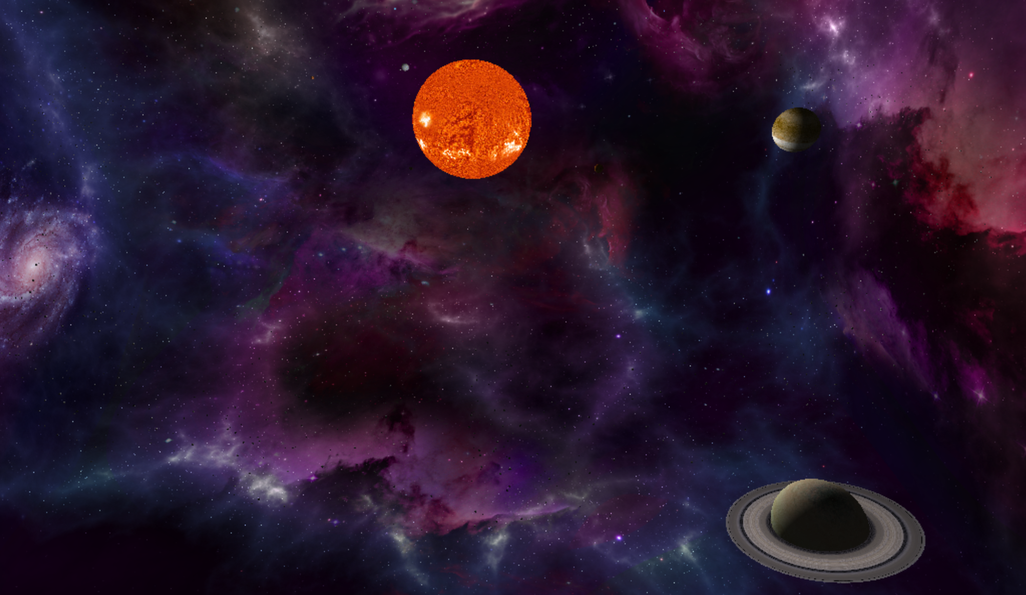

Earth atmosphere

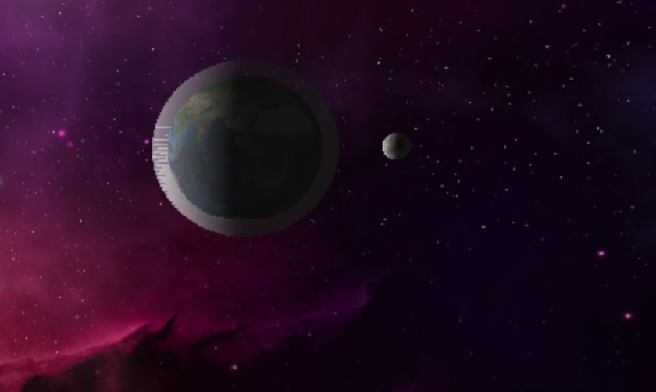

Lighting of planet:

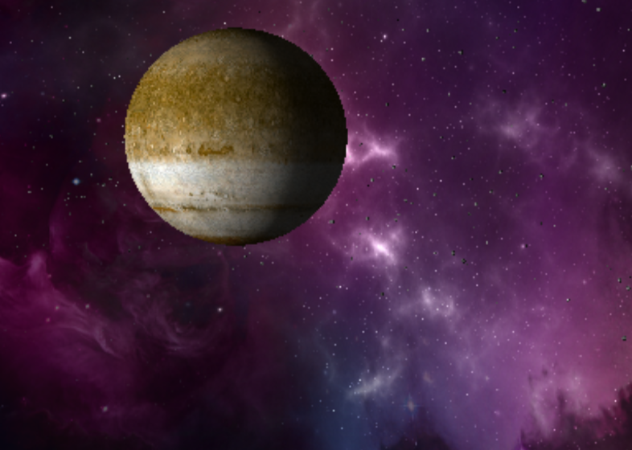

The sun does not have shadow:

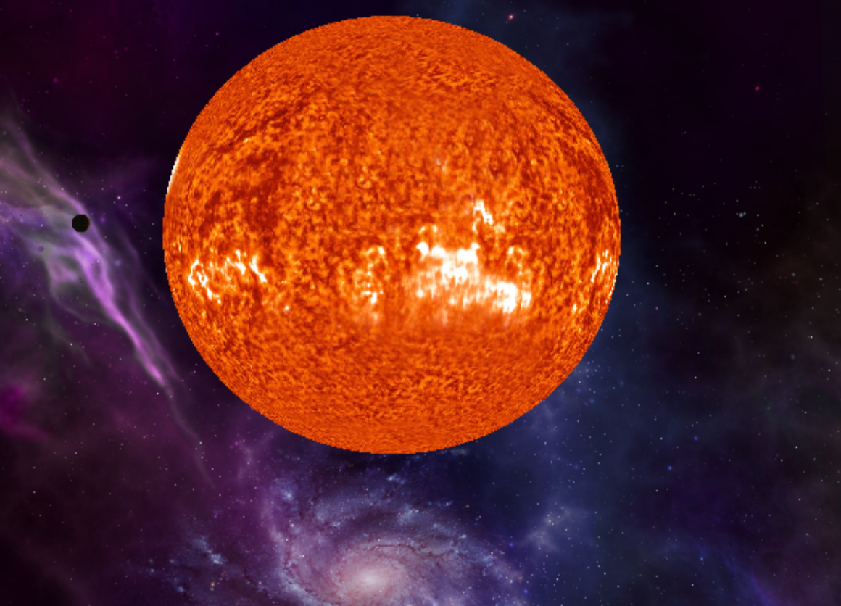

Asteroid belt: each asteroid has random shape

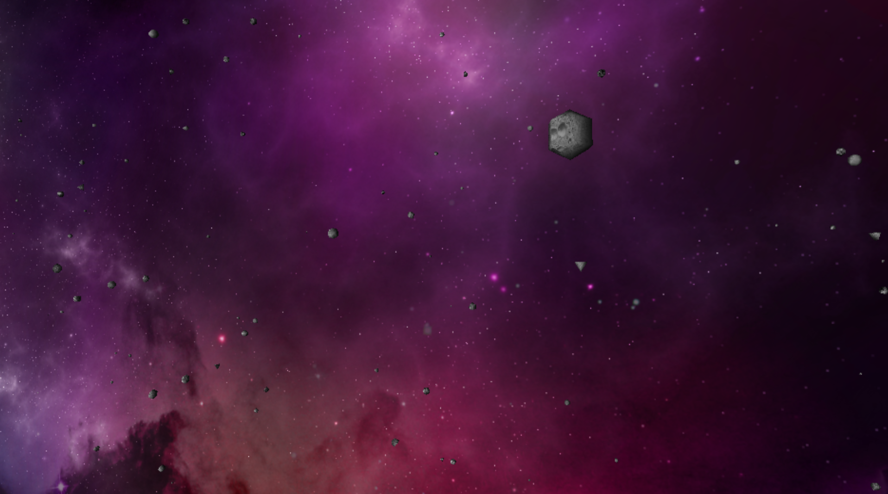

Another view of asteroid belt:

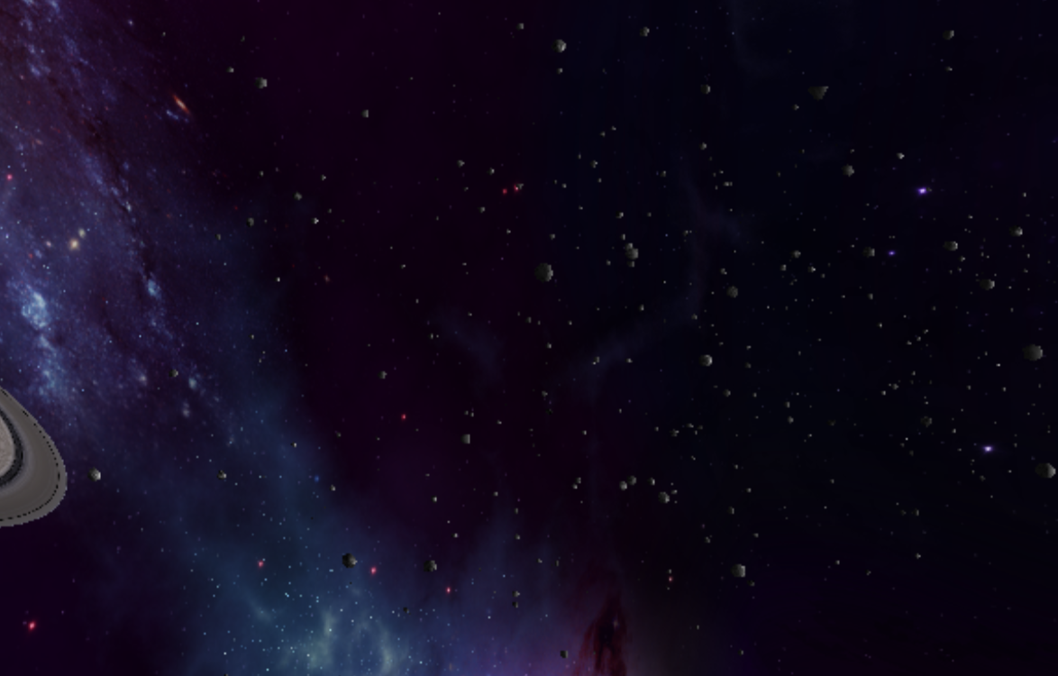

Saturn and Saturn ring:

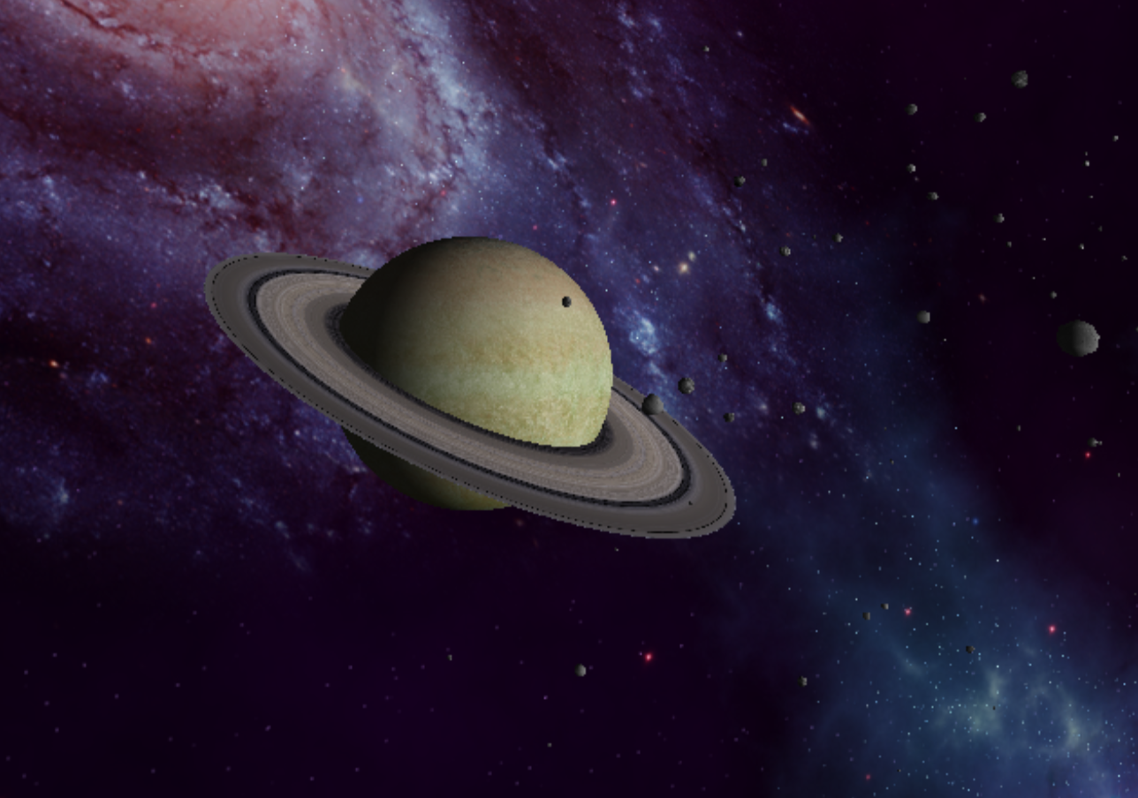

Skybox :

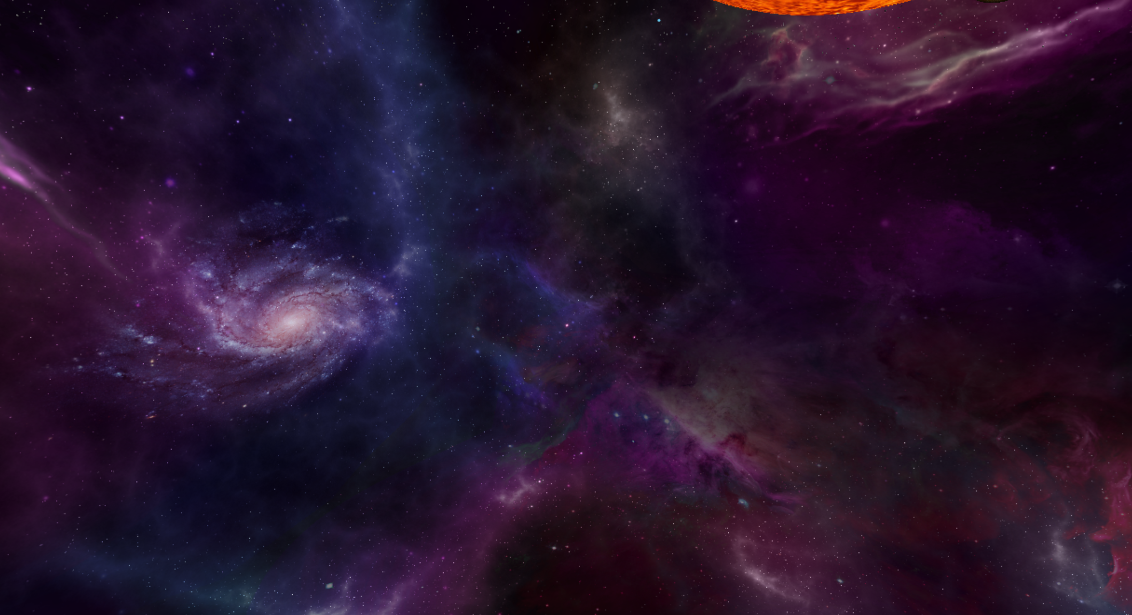

Particle system:

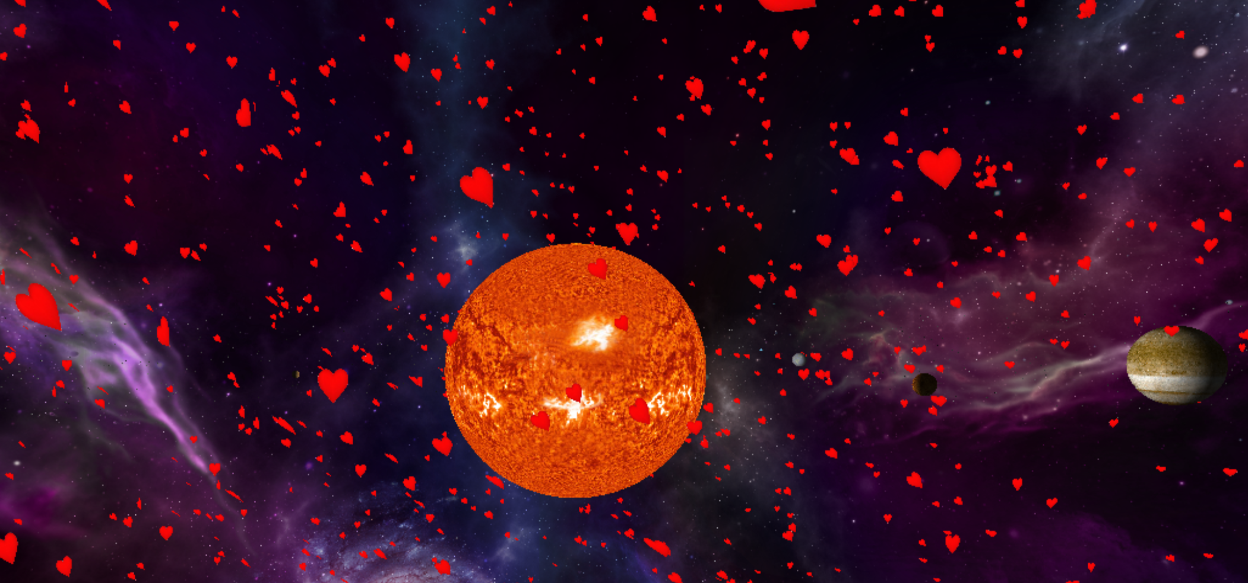

Code:

Different class for the feature:

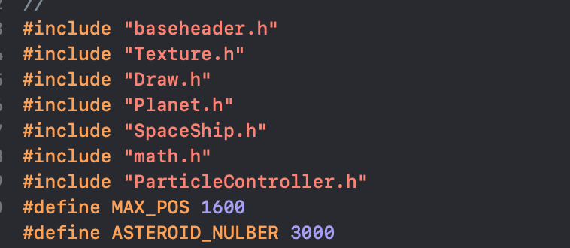

Baseheader: include some base library

SpaceShip: the free camera controller, I intent to make a space ship model, so I abstract this class as SpaceShip.

